PAper TITLE

M. J. Jackson1, Second author's name2, Third author's name3, ...

1First affiliation, City, Country

2Second affiliation, City, Country

3Third affiliation, City, Country

This document is a template for abstract submission to the POF2019 conference. Authors are requested to submit one-page abstract of A4-size (210 x 297 mm) on any of the topics mentioned on our web site. The abstract should be at least 200 words and no more than 500 words.

The abstract is to be written in English and should contain original material not published elsewhere. It should state clearly the scope of the contribution and should concentrate on essential results. Author’s first and middle names are written with initials followed by dot, and family names are written in full. Authors are separated by commas and marked with superscript when necessary to distinguish authors from different affiliations. Author’s are written in lines when there are more than one.

The abstract should indicate key word(s) and your preferred method of presentation either oral or poster. Feel free to include one or two figure(s) or table(s) either in color or monochrome, however, the length of the document must not exceed one page of A4 size. The abstract should be submitted only via internet in PDF format.

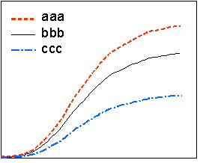

Fig 1. Caption in 10-point font

The content of the abstract will be the basis for acceptance of the paper presentation at the conference. The members of Technical Program Committee will review the abstract and authors will be informed about acceptance of their paper for presentation. The presenter, one of the authors, must register to the conference in advance.

Authors will be required to transfer copyright of the material presented at POF2019 to the International Cooperative of Plastic Optical Fiber (ICPOF).

|  |  |
| --- | --- |
| Key word(s) (maximum of 5) |  |
| Preferred presentation method | □　Oral　　　 □　Poster |